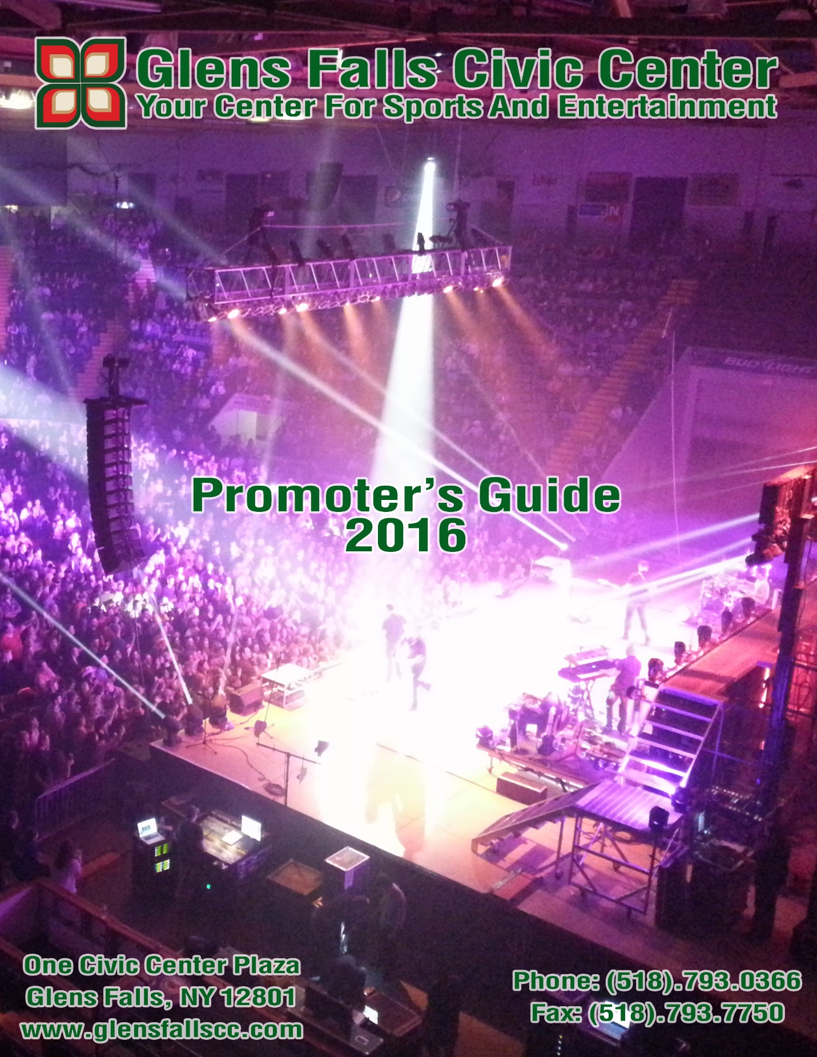

General Information

Glens Falls Civic Center
One Civic Center Plaza
Glens Falls, NY 12801

Phone: (518) 798-0366
Fax: (518) 793-7750
Website: www.glensfallscc.com

Management

The Glens Falls Civic Center is located in New York State, Glens Falls. The arena is managed by The Adirondack Civic Center Coalition, Inc. which is based in Glens Falls NY.

Facility Personnel

General Manager | Jeffrey Mead | jmead@glensfallscc.com Ext. 13
Director of Events | Alyssa Aufiero | aaufiero@glensfallscc.com Ext. 27
Box Office Manager | Avery Giroux | agiroux@glensfallscc.com Ext. 15
Operations Manager | Ron Russell | rrussell@glensfallscc.com Ext. 16
Assistant Operations Manager  Administrative Assistant | Larry DiDio  Heather Cottrell | didiolj@yahoo.com Ext. 16  hcottrell@glensfallscc.com Ext. 10
GLENS FALLS CIVIC CENTER HISTORY

The Glens Falls Civic Center, built in 1979, is a 4,806-seat multi-purpose venue located in downtown Glens Falls, NY. The venue is a full entertainment arena featuring concerts, family shows, consumer shows, and sporting events. The Glens Falls Civic Center is managed by The Adirondack Civic Center Coalition, Inc.

The facility is the home for sports and entertainment in New York’s North Country. Located 50 miles north of New York’s State Capital of Albany, the Civic Center is able to reach nearly 750,000 people throughout the Capital Region, the Adirondacks, and Western Vermont.

The Civic Center accommodates up to 7,562 patrons for an in-the-round performance and also features an ice floor.

The venue also features the 7,335 square foot Heritage Hall, a multi-purpose room available to groups for meetings, banquets, and other public and private events.

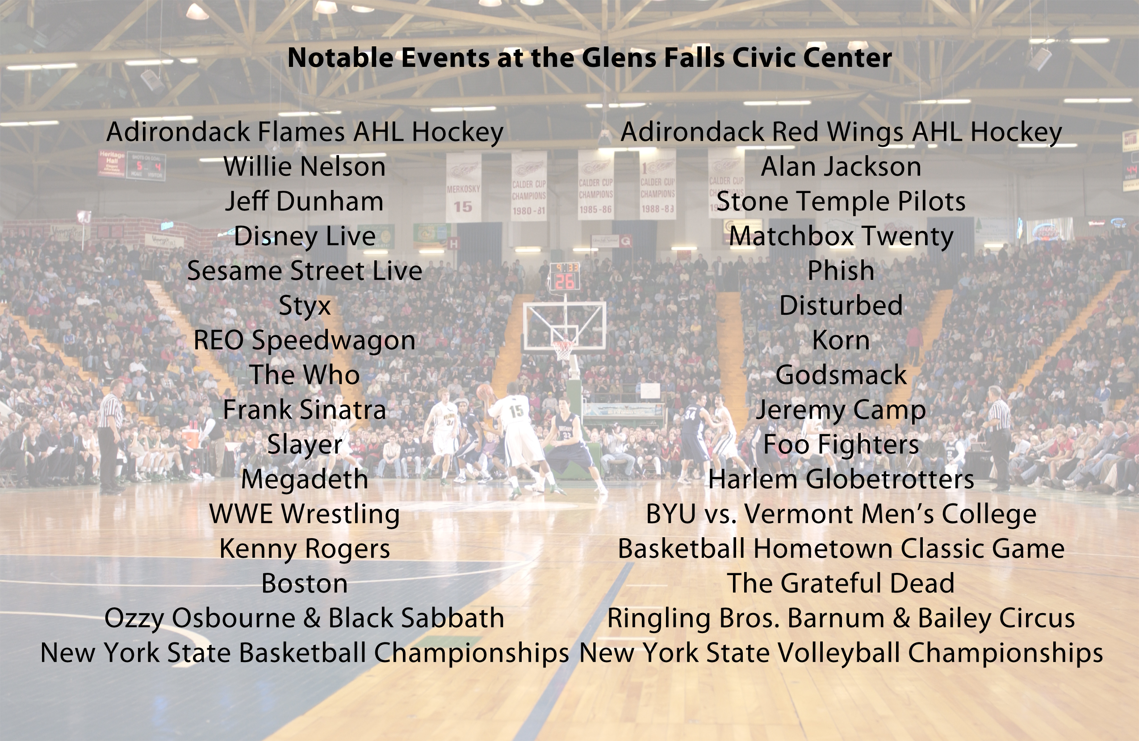

Logistical Information

Dressing Rooms
All dressing rooms are located on the Arena Floor level in the northwest quadrant (stage left).
All rooms are within 60 to 120 feet away, stage left.
- (1) Main Dressing Room/Locker Room w. shower & toilet
- (3) Dressing/Locker Rooms w/ shower and toilet (Two @ 14’ x 22’; one @ 23’ x 26’*)
*Large Room can be divided into 2 separate rooms
- (3) Production offices w/ work area, hard lined internet access and phone jacks
- (2) Crew rooms (both 12’ x 17’)
*Washer & Dryer Available upon request

Electrical Equipment
Fire sprinklers and fire extinguishers are located throughout the arena and office areas. An emergency generator will provide backup sound and light power in case of power failure.

Features for Guests with Disabilities
All entrances to the concourse level of the arena are wheelchair accessible. Designated disabled parking is conveniently located in the Front Plaza. Disabled seating is offered in a variety of locations throughout the venue. Handrails inside the Arena are located on the Northeast seating quadrant. An elevator is located behind Section V with access to all four floors of the venue.

Floor
Arena Floor Dimensions: 15,810 square feet
Floor Type: Finished concrete; 1” Homosote® insulated floor (1” x 4’ x 8’)

Dashers
Plastic with Galvanized Steel. 42” high.

Forklifts (2) | Yale 6,000 lbs. capacity forklift  Max lift ht: 15’  Free fork extensions: 6’ 6”  Fuel system: liquid propane  Tires: pneumatic  Carpet Dork: 12’ | TCM 3,500 lbs. capacity forklift  Max lift ht: 14’  Free fork extensions: 6’ 6”  Fuel system: liquid propane  Tires: pneumatic  Carpet Dork: 12’

Intercom
In-house Clear Com intercom system with patch points on all levels including spot light operators.

Lighting
The house light controls are located in the lighting room on the Press Box level. House lighting consists of dimmable incandescent, high intensity metal halide lights (work lights), and Fluorescent Lighting ringed around the Promenade. Each row of lighting fixtures can be individually controlled and can be dimmed according to specification.

Load-In
Entrance: Oakland Ave. at SW corner of the Glens Falls Civic Center
External Dock: Capabilities for three (3) large transport trailers at dock at once with quick access into Arena and onto floor.
Entry into Arena at Section “M” Portal

Load-in/out Capabilities
Loading Dock- 15’ from Roll-up Doors; Maximum distance to Arena Floor: 50’ Multiple Bus/Truck parking available in dock and back parking area
Load-in Roll-up Doors: 16’ x 15’;
- Box Trucks and Semi are able to back onto Arena Floor for load-in and out.
Storage space is available at loading dock and backstage area.

In-House Staging
Maximum Stage Size: 80’ x 40’ (101 Pieces of 4’ x 8’ staging)
Wenger Staging: 4’ x 8’ increments, adjusted to 4’ or 5’ high
Aztec Wings: 4’ x 8’ increments, adjusted to 4’ or 5’ high
Wood Risers: 4’ x 8’ increments, (44) at 6” high or (60) at 10” high
Stage Drape: Rental available.

Lock and Keys
Locker/dressing rooms may be secured with locks and keys. Keys for each room may be checked out through the Operations Manager. All persons who sign out keys will be responsible for return of the keys at the conclusion of the event.

Marquee
The arena has an outdoor fully animated EverSan marquee.

Scoreboard
The arena has a Barco™ - hung scoreboard measuring 11’ 9” x 14’ 2”, a full color message center. It is located Center House and lifts flush to lower steel.

Spotlights
The Glens Falls Civic Center has four (4) Super Troupers, Long throw five (5) positions available on the catwalk, all wired for Clear Com intercom.

Telephones
Telephones can be installed in any of the dressing/locker rooms or other arena locations. Costing, ordering, and placement can be done by contacting the Event Manager.

Parking
There are 16 parking lots in close proximity to the Civic Center. Lots 5 & 6 can be used for parking of trailers after load-in. There are several additional patron parking lots as well as street parking within 5 short city blocks from the Civic Center (Refer to parking map on Page 19).

Pyro
A New York State pyro permit is required for any pyrotechnics used in the building or anywhere on the premises. There will be a designated ace used for storing pyro. The arena will supply fire extinguishers at the show’s expense. Please contact the city of Glens Falls Dept of Fire Safety for permit filing and information.

Runners
The Arena can provide runners upon request. Our runners come with a standard passenger car. If you have any requirements other than this (vans, trucks, etc…), please let us know in advance and we can rent at your cost. Runners will be paid by the show a minimum of $150.00 per day plus any tolls, gas or other expenses incurred by running.

Seating/Chairs
General fixed seating is made up of Irwin chairs with cushioned backs and bottoms. Disabled seating is located at various locations throughout the Arena. Portable chairs are upholstered and interlocking for use on the arena floor (depends on event set-up).

Drapery/Soft Goods
We can provide a variety of drapery to fit your needs, from pipe & drape to truss and drapes travestying the width of the Arena. Please contact the Event Manager for details and options.

Rigging
(Note: Refer to rigging plot on Page 14)
Height from floor to low steel: 44’ 6”
High Beam to Floor: 64’ 6”
Low Beam to Ceiling: 20’
Truss Height: As Needed
End Stage Set: 75,000 lbs.

RENTAL RATES AND CONDITIONS

Equipment and Service Rates
The Glens Falls Civic Center provides a full-range of event equipment and personnel including ushers, ticket-takers, stagehands, cleaning, operations, and technical support. Rental rates are dependent upon contract terms.

Rental Rates
Per day facility rental rates are available upon request. All rental rates are negotiable and dependent upon contract terms. Please call (518) 798-0366 for rates.
Taxes: New York State tax is 7% on all revenue.

Available equipment
(Rental and rates subject to contract terms):

- Stage/chair/barricade
- Staging
- Basketball Floor
- Barricade
- Bicycle Rack
- Outdoor Marquee
- Risers
- Barriers
- Spotlights
- Forklifts
- Tables (8ft. only)
- Tables (skirted, each, per day)
- Pipe and Drape (limited quantity)
- Furniture
- Sound System and audio headsets
- Telephones
- Telephone long distance
- Wireless and hard line internet
- Shore power

Deposit Requirements and Procedures
A deposit is required as consideration in order to secure a date at the Arena and/or in Heritage Hall. This amount is due upon execution of the contract or whenever another potential user challenges a date. In case of multiple events, the Glens Falls Civic Center will hold the deposit as a floating deposit unless those dates are challenged, in which case the promoter must provide the additional deposit for each sum in advance as a damage deposit, which is refundable after the event is settled and when a check of the facility is completed. Management further reserves the right to require a deposit to cover all estimated expenses, including but not limited to: rent, ticketing fees, set-up, staffing, damages, advertising, electrical services, and miscellaneous equipment.

I.A.T.S.E. STAGEHAND GUIDELINES
Union: Local #524 I.A.T.S.E.
Union Steward/Business Agent: Colleen Grignon/Ed Smith
Union President: Adrien Dubee
Loaders Separate: Yes
Minimum Calls: - Minimum two men for any show-related work
- Minimum three riggers (2 up, 1 down), but only if
rigging is actually needed.
- Supervisory shop steward required when call is 9
people more than; working steward for calls under 9.
- Stagehands, grips, gaffers, and wardrobe shall be paid
a minimum of 4 hours on the load-in and 4 hours on
the load-out (Loaders: 4 hours on load-in).
- For trucks over 22’ there must be a minimum four
person loader crew
Performance Call: Four (4) hours (including 30 minute pre-show call)
Crew split for lunch: Yes
Coffee Break: 10 minutes in the misled of any 5-hour work period.
Meal Break: 1 hour at the end of any continuous 5-hour work period.
All crew on until Sound Check: No
Focus: Union focuses upon request, extra charge
Any Split Jurisdiction: No
Breaks required before Outcalls: See meal and coffee break above.
Stop Work during Breaks/Meals: Show option.

Commercial Rates: For a performance that is to be recorded or live by a national or regional television network ether by way of audio or regional mediums for reuse or presentation, there shall be an additional charge above the prevailing rate. Rates are $5/hour and/or $7.50/hour for overtime.

Overtime: Time and one half the straight-time hourly rate shall be paid after any eight consecutive hours. Any hours worked between midnight (00:00 hours) and 8:00 a.m. (08:00 hours) shall be paid at time and one half the hourly rate. A performance call shall not be included to compute overtime when in conjunction with an in or an out. Any overtime rate shall include a break after five (5) hours of work.

Holidays: Time and one half straight-time hourly rates, or time and one half the straight-time performance rates, whichever is applicable, shall be paid for all holidays worked. This rate shall continue to apply to any call beginning on a holiday and continuing into the hours of the following day. The following are designated holidays: New Year’s Day, President’s Day, Memorial Day, Independence Day, Labor Day, Thanksgiving, and Christmas Day. All hours worked on a designated holiday exceeding eight (8) hours will be paid at two (2) times the applicable hourly rate.

Box Office/Ticketing
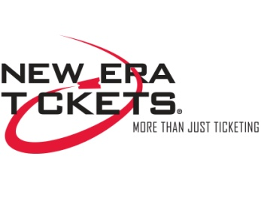
The Glens Falls Civic Center is affiliated with New Era Tickets. Tickets to Arena events are available at the Arena Box Office, by phone at (518) 798-0202 & 1-855-GFCC-TIX, on-line through the Internet at www.glensfallscc.com and at registered New Era Ticket outlets. The Glens Falls Civic Center’s normal Box Office hours are Monday through Friday 10 AM–6 PM, Saturday 9 AM—2 PM. The Box Office is also open Sunday on day of events.

Food and Beverage
All food, beverage, and concessions are operated and controlled by the Glens Falls Civic Center. All arrangements for catering, and food and beverages service should be made through our Event Manager. We have recently upgraded all of our Arena’s concession stands with exciting new food items and designs to match what our customers are looking for in food service. Catering contracts are available through the Event Manager. For outside catering, the Arena works with some of the finest restaurants in Upstate New York in order to provide a variety of options to suit your needs. Please forward backstage and beverage requirements to the Arena at (518) 798-0366 or fax at (518) 793-7750

Meeting Room Space
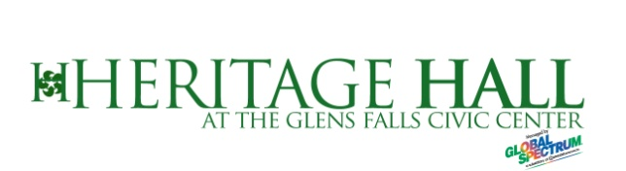
The Glens Falls Civic Center offers the Birch, Maple, and Adirondack Booster Club meeting room space in Heritage Hall for promoters and local businesses throughout Warren, Washington, and Saratoga counties. These rooms are equipped with a multitude of different setup capabilities, including access to a fully-functioning bar, quality-sized kitchen and restaurant-style facility. Heritage Hall has a maximum occupancy of 468 for banquet seating and 600 for assembly seating. The Hall is handicap-accessible with adjacent restrooms and an elevator.

Heritage Hall is located on the second level of the Glens Falls Civic Center and can be subdivided into 3 smaller rooms;
- Adirondack Booster Club Room -- w/ full service bar and kitchen access
Room Area: 39’ x 45’
(2) Maple Room – Wireless Mic & PA system
Room Area: 50’ x 45’
(3) Birch Room – Wireless Mic & PA system
Room Area: 74’ x 45’

Heritage Hall total area is 163’ x 45’ and has a ceiling of 10’. Stairwells have direct access to the Arena Floor and Dressing Rooms and can be used for extra Dressing Room Space. Heritage Hall is handicap accessible with elevator access to all 4 floors. Contact your Event Manager for capacities of each room.

Merchandise/Novelties
The Arena sells merchandise and will retain a percentage of net merchandise/novelty sales, dependent upon the event contract. Net sales shall be gross receipts minus credit card fees. New York State may also require a vending permit. Please contact us for additional information.

Marketing Services
The Glens Falls Civic Center’s in-house marketing department can assist with the numerous details involved to successfully market your event. For a negotiated fee (based on time, labor, and expense) the Glen Falls Civic Center can also assist with promotions, public relations, and the publicity needed to ensure ticket sales.

Local Media

Print

Print support comes from;

The Post-Star
- (circ. Mon-Sat: 33,667; Sun: 35,851)
The Chronicle
- (circ. Weekly: 30,000)
The Saratogian
- (circ. Mon-Sat: 8,500; Sun: 10,000)
Metroland
- (Thurs Only: circ. 100,000+)
Community News
- (Fri Only: circ. 23,000)
The Albany Times Union
- (circ. Mon-Sat: 53,521;
Sun: 111,780)

Television

WNYT / Ch. 13……………...NBC Affiliate
WRGB / Ch. 6 ………………CBS Affiliate
WXXA / Ch. 7……………….FOX Affiliate
WTEN / Ch. 10……………...ABC Affiliate
WCWN / Ch. 15……………..CW Affiliate

Radio

WRVT / 88.7 FM………...Public Radio
WMHT / 89.1 FM………...Classical
WSSK / 89.7 FM…Christian Contemporary
WXLG / 89.9 FM………....Public Radio
WAMC / 90.3 FM………...Public Radio
WLJH / 90.7 FM…Christian Contemporary
WNGN / 91.9 FM………...Religious
WFLY / 92.3 FM……….Top 40
WGFR / 92.7 FM………..ACC (College)
W228BO(WXLG)/ 93.5 FM……Public Radio
WNYV / 94.1 FM………Adult Contemporary
WBAR/ 94.7 FM………Religious
WVTQ / 95.1 FM………Classical
WYJB / 95.5 FM………Adult Contemporary
WCQL / 95.9 FM…….....Hot AC
WZRT / 97.1 FM……...Top 40
W247BJ (WXLG) / 97.3 FM……Public Radio
WJJR / 98.1 FM……….Adult Contemporary
WCKM / 98.5 FM……….Oldies
WRVE / 99.5 FM………. Hot AC
WFFG / 100.3 FM……….Country
WJKE / 101.3 FM………..Hot AC
WNYQ / 101.7 FM………Classic Hits
WEQX / 102.7 FM……….Alternative
WMNV / 104.1 FM………Religious
WBLN (LPFM) / 104.9 FM……..Religious
WJEN / 105.3 FM………..Country
WQSH / 105.7 FM………Classic Hits
WPYX / 106.5 FM………Classic Rock
WKBE / 107.1 FM……..Alternative
WGNA / 107.7 FM……….Country

WROW / 590 AM………...Oldies
WNNZ / 640 AM………….Public Radio
WGY / 810 AM…………..News / Talk
WOFX / 980 AM…………Sports
WAIX / 1160 AM………..Hot AC
WMML / 1230AM……..Sports
WENU / 1410 AM………Sports
WWSC / 1450 AM………Talk
WDCD / 1540 AM……….Religious

Seating Capacities:
- Permanent Seating: 4,806
- Ice Hockey: 4,806
- Basketball: 5,475
- In the Round: 7,562
- End Stage: 6,778

Event Set-Up Possibilities:
- Ice Hockey, Figure Skating, Ice Show
- Basketball
- Boxing, Wrestling
- Circus, Rodeo
- Trade Show – Arena Floor
- Trade Show, Banquet – Heritage Hall
- End Stage, Half-House Concerts, Comedy Shows, Family Shows

Seating Charts

Basic / Hockey Layout

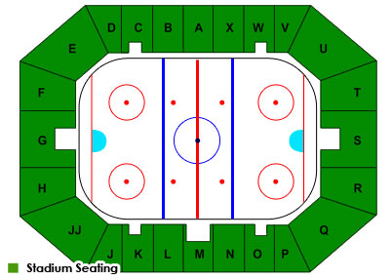

Concert - Seating | Concert – General Admission
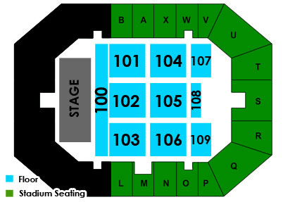 | 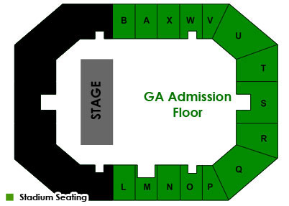
Family show | Basketball
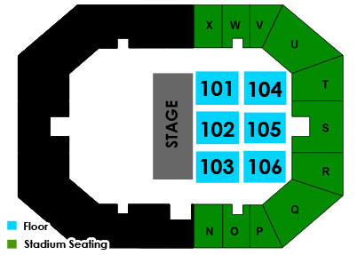 | 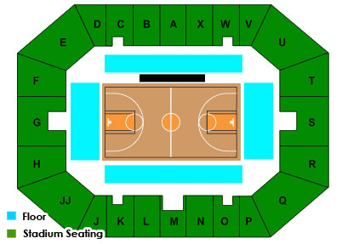
Wrestling | Ice Show
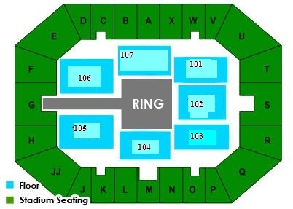 | 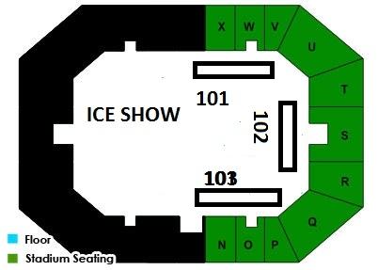

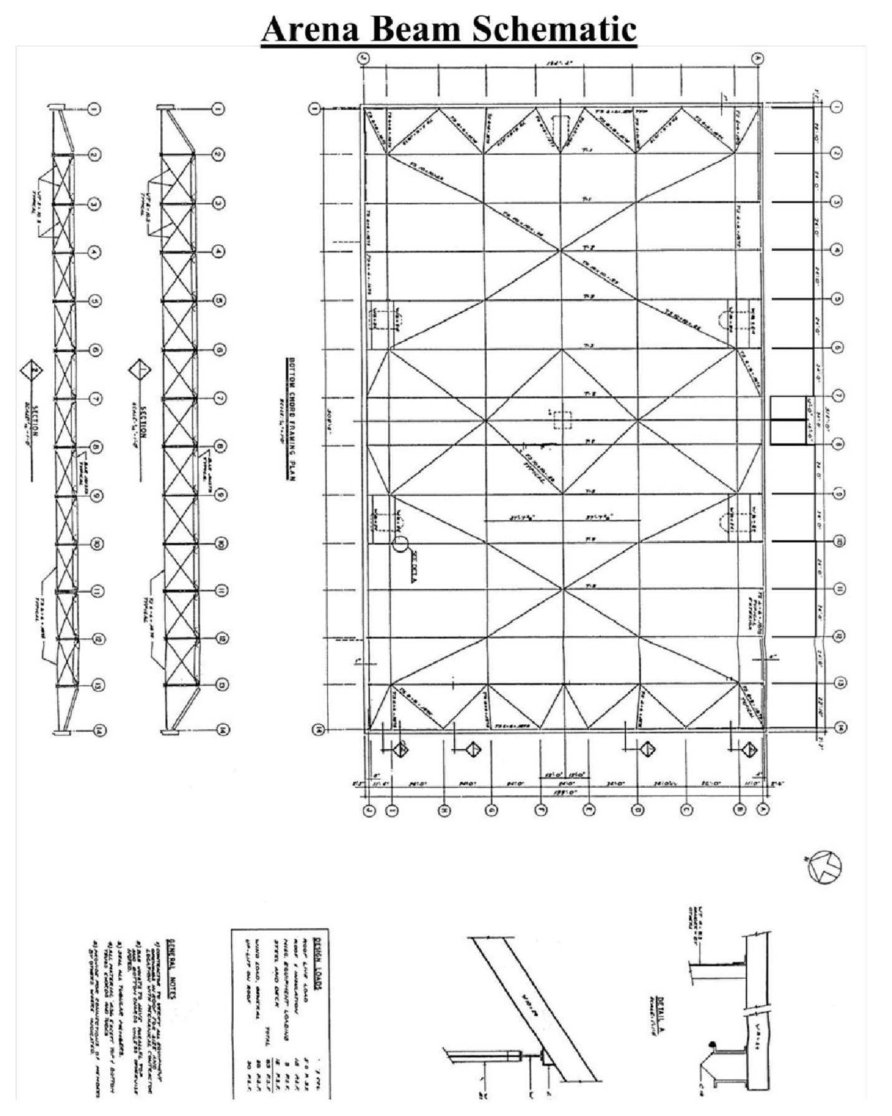

LOCAL BUSINESSES & ATTRACTIONS
The following facilities may be contacted directly or through the Event Manager

Equipment Rental Companies
- Adirondack Scenic, Inc. Argyle, NY (518) 638-8000
- Allerdice Rent-All Saratoga, NY (518) 584-0002
- Clifton Park Rental Center Clifton Park, NY (518) 877-7449
- Creative Stage Lighting North Creek, NY (518) 251-3302
- High Peaks Light and Sound Saratoga, NY (518) 222-0151
- NES Rentals Queensbury, NY (518) 792-2204 Advance Rental Supply Queensbury, NY (518) 792-2222

Lodging
- Country Inn & Suites Queensbury, NY (518) 745-0180
- Fort William Henry Lake George, NY (800) 234-0267
- Hampton Inn & Suites Lake George, NY (518) 668-4100
- Holiday Inn Resort Lake George, NY (518) 668-5781
- Queensbury Hotel Glens Falls, NY (518) 792-1121
- Ramada Inn Queensbury, NY (518) 793-7701
- The Sagamore Resort Bolton Landing, NY (518) 664-9400
- Six Flags Great Escape
& Indoor Waterpark Queensbury, NY (518) 824-6000
- Sleep Inn & Suites Queensbury, NY (518) 955-3000

Day Spas
- Body Relief & Spa Queensbury, NY (518) 792-6196
- The Sagamore Resort Bolton Landing, NY (518) 644-9400
- The Spa Studio & Salon Glens Falls, NY (518) 745-6909

Emergency (Dial 911 or…)
- Empire Ambulance Service Glens Falls, NY (518) 480-4944
- Glens Falls Hospital Glens Falls, NY (518) 926-1000
- Glens Falls Police Department Glens Falls, NY (518) 761-3840

Entertainment
- Aviation Mall Queensbury, NY (518) 793-8818
- Hiland Golf Club Queensbury, NY (518) 793-2000
- Saratoga Racecourse (seasonal) Saratoga, NY (518) 584-6200
- Saratoga Raceway & Casino Saratoga, NY (518) 584-2110
- Six Flags Great Escape Lake George, NY (518) 792-3500
- Top of the World Golf Course Lake George, NY (518) 668-2062
- The Sagamore Resort Golf Course Bolton Landing, NY (518) 644-9400
- West Mountain Ski Center Queensbury, NY (518) 793-6606

LOCAL BUSINESSES & ATTACTIONS (cont’d)

Restaurants/Take-Out
- Bogey’s Pub & Grill Queensbury, NY (518) 792-1560
- Carl R’s Café Queensbury, NY (518) 793-7676
- Cirelli’s Osteria South Glens Falls, NY (518) 636-5090
- Cooper’s Cave Ale Company, Ltd Glens Falls, NY (518) 792-0007
- Dango Fitzgeralds Irish Steakhouse Saratoga Springs, NY (518) 584-2022
- Davidson Brothers Brewpub Glens Falls, NY (518) 743-9026
- Denny’s (24 hrs.) Queensbury, NY (518) 798-4388
- Docksider Restaurant Lake George, NY (518) 792-3534
- Downtown City Tavern Glens Falls, NY (518) 480-3500
- Farm House Grill Lake George, NY (518) 668-3000
- Gourmet Café Glens Falls, NY (518) 761-0864
- Hometown Smoothies Glens Falls, NY (518) 816-1234
- Log Jam Lake George, NY (518) 798-1155
- O’Toole’s Restaurant/Pub Queensbury, NY (518) 793-3389
- Raul’s Fresh Mexican Grille Glens Falls, NY (518) 761-1180
- Steve’s Place Glens Falls, NY (518) 793-5855
- Talk of the Town Glens Falls, NY (518) 798-3348

Transportation
- Adirondack Trailways Glens Falls, NY (800) 858-8555
- Albany International Airport Albany, NY (518) 242-2200
- Amtrak Rail Service Fort Edward, NY (800) 872-7245
- Empire East Aviation, Inc. Glens Falls, NY (518) 798-3091
- Floyd D. Bennett Mem. Airport Glens, Falls, NY (518) 792-5995
- Greyhound Bus Lines Glens Falls, NY (800) 231-2222
- Hollywood Limousine Glens Falls, NY (518) 792-4871
- Rentals by Ringer Hudson Falls, NY (518) 747-0636
- White Knights Limousine Service Troy, NY (518) 664-4679

RULES AND REGULATIONS

Alcohol
No alcoholic beverages may be brought into the Glens Falls Civic Center. Alcoholic beverages will be sold by Food and Beverage services during events.

Cameras and Recording Devices
As a general rule, cameras and recording devices of any kind are not permitted inside the Arena. This is subject to change on an event-by-event basis.

General Rules
- The cost of removing excessive tape will be the responsibility of the talent.
- Stickers and adhesive backed decals are not to be given out in or around the building.
- Nails and screws are not to be driven into the arena floor or walls.

Guest Conduct
The Glens Falls Civic Center strives to provide its guests with a safe, comfortable, and enjoyable atmosphere. Therefore, the Arena has established the following guidelines:

- Guests interfering with other guest’s ability to enjoy the event may be subject to ejections.
- Guests using foul or abusive language, or inappropriate or unacceptable gestures may be ejected from the Arena
- Guests appearing impaired may be ejected from the Arena and turned over to the authorities.

Guidelines for Exhibiting Motorized Vehicles
- There shall be no refueling of vehicles inside the building.
- Vehicle keys must at all times be readily available to the Glens Falls Civic Center Management.
- Keys for unattended vehicles remaining overnight must be given to the Glens Falls Civic Center management.
- There shall be no more than ¼ of a tank of gasoline or 5 gallons per vehicle.
- There should not be any storage of flammable fuel in the building except for that which is in the vehicle.
- There shall be no work done on the vehicle inside the building unless authorized by Glens Falls Civic Center management.
- Fuel tank doors must be locked or fuel caps taped shut.
- Vehicles will not be started except for move in or move out.
- Cleaning of vehicles is the responsibility of the vehicle owner and must follow Arena policies.

Leaflets/Brochures
Distribution of any printed materials, or selling of any times is prohibited on the Glens Falls Civic Center grounds including the parking lots, walkways, and inside the Arena unless permission from the Arena has been granted.

Re-Entry into Arena
General policy of the Civic Center is once a patron leaves an event there is no re-entry to the event. This policy can be changed per event/promoter request.

Re-selling of Tickets
Re-selling of tickets by private parties is prohibited on Glens Falls Civic Center property.

Selling of Illegal Merchandise
Selling of illegal merchandise is prohibited on Glens Falls Civic Center property as well as by law.

Smoking
Smoking is not allowed in any public facility in Glens Falls, NY.

Sponsorships
The Glens Falls Civic Center owns signage rights inside and outside of the Arena.
Tenants wishing to display advertising signs or banners must be pre-approved by Glens Falls Civic Center management.

The following items are prohibited in the arena:
- Aerosol cans
- Air horns
- Alcoholic beverages or illegal drugs
- Animals (except certified service dogs for the disabled)
- Backpacks and excessively large purses
- Beach balls and other inflatables
- Bota bags of wine skins
- Bullhorns or noisemakers
- Cameras (varies on events)
- Confetti
- Face/body paint
- Fireworks, firearms, or other weapons
- Framed backpacks
- Glass bottle or aluminum bottles
- Ice chests or thermo containers
- Laser pointers
- Outside food or beverage

Parking Areas
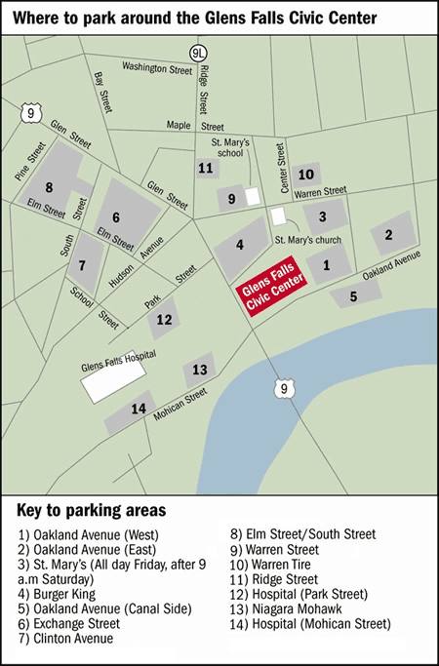

Number of Parking Spots:
1) | Oakland Avenue (West) | 66 Spaces | 10) | Warren Street | 35 Spaces
2) | Oakland Avenue (East) | 57 Spaces | 11) | Warren Tire | 45 Spaces
3) | St. Mary’s | 102 Spaces | 12) | Ridge Street | 31 Spaces
4) | Burger King | 108 Spaces | 13) | Hospital (Park Street) | 216 Spaces
5) | Oakland Avenue (Canal) | 40 Spaces | 14) | Sawyers | 100 Spaces
6) | Exchange Street | 167 Spaces | 15) | Niagara Mohawk | 220 Spaces
7) | Clinton Avenue | 48 Spaces | 16) | Hospital (Mohican Street) | 207 Spaces
8) | Elm Street/South Street | 140 Spaces | 17) | Hospital (School Street)
9) | Elm Street | 105 Spaces

Directions to the Glens Falls Civic Center

From the North
Take I-87 (Adirondack Northway) south to Exit 18. Turn left at the end of the ramp onto Main Street. Go straight through five traffic lights. This will put you at a fork in the road with a Stewart’s shop in the middle. Bear right onto Hudson Street. Go straight.
At the fourth traffic light, turn right onto Route 9 south. The Civic Center is on your left-hand side as you start down the hill.

From the South
Take I-87 (Adirondack Northway) north to Exit 18. Turn right at the end of the ramp onto Main Street. Go straight through five traffic lights. This will put you at a fork in the road with a Stewart’s shop in the middle. Bear right onto Hudson Street. Go straight.
At the fourth traffic light, turn right onto Route 9 south. The Civic Center is on your left-hand side as you start down the hill.

From the East
Take I-90 (New York State Thruway) to Exit 24. Follow the signs to I-87 (Adirondack Northway) to Montreal/Saratoga Springs. Take I-87 (Adirondack Northway) north to Exit 18. Turn right at the end of the ramp onto Main Street. Go straight through five traffic lights. This will put you at a fork in the road with a Stewart’s shop in the middle. Bear right onto Hudson Street. Go straight.
At the fourth traffic light, turn right onto Route 9 south. The Civic Center is on your left-hand side as you start down the hill.

From Rutland, Vermont
Take Route 4 to Fort Ann, NY. Turn right onto Route 149. Follow this to the junction of Routes 149 and 9 South. Turn left onto Route 9 South.
Follow Route 9 South for exactly 5.5 miles. Civic Center is on the left-hand side as you start down the hill.

From the West
Take I-90 (New York State Thruway) to Exit 24. Follow the signs to I-87 (Adirondack Northway) to Montreal/Saratoga Springs. Take I-87 (Adirondack Northway) north to Exit 18. Turn right at the end of the ramp onto Main Street. Go straight through five traffic lights. This will put you at a fork in the road with a Stewart’s shop in the middle. Bear right onto Hudson Street. Go straight.
At the fourth traffic light, turn right onto Route 9 south. The Civic Center is on your left-hand side as you start down the hill.

